Hancock County Arts
Fall will be here, from pumpkins and apples to corn stalks and squash, autumn has many symbols. And Hancock County will bring these colors to life through September and as fall begins, it is one of the beautiful times to be an artist in Indiana.
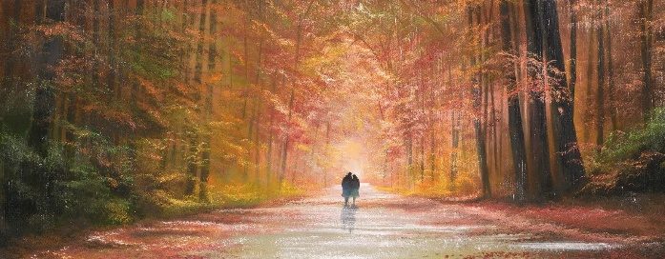
____________________________________________

- September AT THE GALLERY 2nd Friday
- Hi-Lighted Member
- Classes/Studio Time in Hancock County
- October AT THE GALLERY
- Register - Diamonds and Denim Gala, October 22
- A “Pause for Words"
- Artist Call Out
- Just a Note-For Artists
____________________________________________

SEPTEMBER, At the Gallery, 2nd Friday, 6:30-8:30 PM
Friendship, Adventures and Creativity
By Sandy Hall and Mary Cork
Wonderful show of their travels, includes China, Taos, Greece, Puerto Vallarta, Kefalonia and more.
Musicians Angela Meckler Violinist and Nancy Nickels, Harpist will perform.
____________________________________________

Member Highlight – September 2022
We would like to introduce or re-introduce all of you to Paul and Judy Fedorchak. Paul Fedorchak joins your Hancock County Arts Council Board of Directors.

Inspired by the ceramics’ passion of their daughter, Paul and Judy Fedorchak became members of Hancock County Arts a few years ago. Their interest started as a way of showing appreciation for the support given to ceramic artist Emily by those involved in the organization and its Twenty North Gallery. Fast forward a few years and Paul recently accepted an invitation to join the board.

Do not put a paint brush or clay in Paul’s hands and expect to see a treasured piece of art. Instead, he uses his skills as a wordsmith to spread news of the talent of those in the arts community. He’s been touting the successes of Hancock County residents since arriving in 1984 as editor of the Daily Reporter, where he served until 1996 before moving on to other Indiana media. He has also worked in the social services community, Greenfield-Central schools, and the Indiana Department of Transportation real estate division, where he remains today.

Since he has called Greenfield home for 38 years, Paul has many relationships which he hopes will help grow the image of Hancock County Arts, its members, and the artists it spotlights.

Paul, and Judy, who is a recently retired Triton Central High School English and speech teacher, are both Franklin College graduates. Judy recently returned to the classroom to teach adult English Language Learners. Daughter Emily is managing an arts center in western New York and teaching ceramics classes. Their son, Steven, is a graphics artist in Columbus, Ohio, and his twin sister, Paige, is an accountant in Louisville.

Hancock County Arts is excited to have Paul join us.
____________________________________________

Annual Chalkfest in the Living Alley.
September 17, register and reserve for your space online
Join in and Chalk!
inviting Businesses to Chalk their Walks!
See all the artwork throughout Hancock County!
____________________________________________

Classes/Studio Time Throughout Hancock County

Time to register!

AT our TwentyNorth Gallery/Register Online www.hancockcountyarts.org for classes, questions contact hancockcountyarts@gmail.com

Open Fiber 1st Thursday ea. month, see you Sept

Open Studio Each Tuesday, 9 – 12

Still Life Each Thursday 1 – 4

Sept. 7, Sandy Hall Watercolor Class, $30, Register Online. All supplies included.
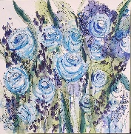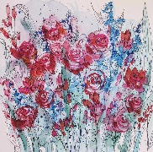

Sept. 11, Fall Home Décor with TY Creations, $10, Register Online
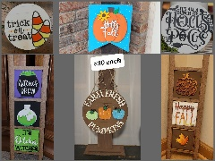
Sept. 15, Cricut Class, $35, Register Online
This class will cover the basics of your Cricut machine and Cricut Design Space. The goal is that you will feel more comfortable using your wonderful cutting machine and you will take home a decorated gift bag.
Bring your computer, Cricut (Explore family, Joy, or Maker), tools (weeder, spatula, scraper, scissors), cutting mat and a tape gun or other adhesive. Jeni will provide: Ideas, the bag, designer color paper and embellishments Cricut beginners’ class, learn about using your Cricut and make a gift bag.
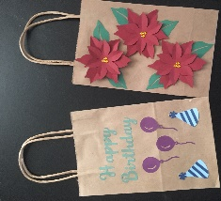

Sept. 17, Dianne Hoover Life Expressions Décor, $35, Register Online
Create your own sign! Dianne will bring Dozens of options of wording & wood! You will leave with beautiful decor for you or for a gift!

Sept. 22, Cricut Class
Paper Flowers Cricut class will give you the opportunity to make a variety of flowers. We will do rolled flowers and a poinsettia.
Bring your computer, Cricut (Explore family, Joy, or Maker), tools (weeder, spatula, scraper, scissors), a cutting mat and a hot glue gun or other adhesive. Jeni will provide: Designer color paper, skewers (for stems) and embellishments. Make beautiful flowers using your Cricut, just in time for fall and Christmas.
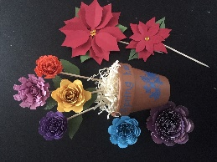
Sept. 25, Fall / Halloween Home Décor with TY Creations, $10, Register Online

AT The Gilded Nest 12 W. Main Street, 317.318.2191 Call to register for each
Every Monday 6pm: watercolor class with Michelle Kimberlin $35
Every Wednesday 4pm: Kid's class with Michelle Kimberlin $35
September, David Kearns with Pottery Sessions
____________________________________________

OCTOBER, At the Gallery, 2nd Friday, 6:30-8:30 PM
Members Best Show -Members bring pieces and we will display one as the best. We will wow the Riley Festival Visitors. Intake is 9/29 – 9/30.

10/6-10/9 Hosting the Riley Festival Art Exhibit & Pumpkin Decorating Contest
10/22 Diamonds and Denim Auction for the Arts Gala TIME TO REGISTER TO BID ONLINE
10/23-10/31 Festival of the Jack-O-Lantern 7 - 9 ea. night @ Riley Gardens

Oct. 2, Needle Felting Workshop
Create pumpkin with Ann Brown, Register Online
$25 for 1 pumpkin, $35 for 2 pumpkins

Oct 18, Floral Arrangement, 6-8 PM, $35, Register Online
Learn the Secrets to Creating Your Own Pumpkin Floral Arrangement Emily's Backyard Blooms
____________________________________________

Diamonds and Denim Gala
Online Auction for the Arts
October 22, 2022
SAVE THE DATE
You may bid on many items; new ones are added daily.
One is tickets for “Straight No Chaser” December Performance
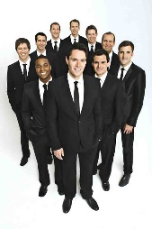
Bidding begins October 1, 2022
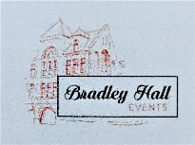
At Bradley Hall Event Center
Time to Register and Purchase Tickets to the Gala
www.biddingforgood.com/HANCOCKCOUNTYARTS/

____________________________________________

A "Pause for Words"








  !"
#!
Sounds of Late Summer
Cicadas drone, crickets chirp,
tree frogs bark, along with a
neighbor’s dog. Children laugh,
katydids sing in ch-ch-ch rhythm.

Pileated Woodpeckers drum,
a pair of northern cardinals trill,
eastern bluebirds warble, creating
a comforting late summer chorus.

Lylanne Musselman is an award-winning poet and visual artist, who lives with her cats and creates in Eaton, IN. She is a member of Hancock County Arts, and currently is president of Muncie Artists Guild. She recently became director of the Blackford County Arts Center. Check out her website: Lylanne Musselman – Artist – Poet – Playwright (wordpress.com)

____________________________________________

Call Out
Coloring book line drawings
Volume III coloring book featuring - “Good Scenes, Love and Life”, real or imagined, all Artists are eligible to submit an original line drawing. Donors are asked to complete a line drawing in felt tip or ink, approximately 7 inches wide by 10 inches high, and write a brief paragraph about themselves. The bio paragraph will be included in the book. Artists can opt to include their website and contact information to promote their work.

Submissions are due by September 15, 2022. High resolution digital images at least 300 dpi can be emailed with the bio paragraph to our Fundraising Chair at HancockCountyArts@gmail.com.

____________________________________________

Just a Note!
Hey, Artists, be sure we have your website on our website. Send a bio, telling us your medium. We have visitors asking about commissions. We are posting members artwork for sale, also. Send the information to HancockCountyArts@gmail.com
Watch for 1828 An Art Fair on Facebook. Planning a fine art fair in 2023.
Check it out and participate.
Thank you.
____________________________________________

Our Mission
Hancock County Arts will
provide leadership for the creative community
by encouraging, celebrating, and promoting arts and culture
throughout Hancock County.
Open Wednesdays, Thursdays and Saturdays
11 till 2
Open for private showings, contact us.
hancockcountyarts@gmail.com
www.hancockcountyarts.org
20 N State Street
Greenfield, IN
317.967.2461
BE PART OF THE ARTS!

